Ramanujan College


University of Delhi

GE-4:COMPUTER SCIENCE INFORMATION SECURITY AND CYBER LAWS

SUBMITTED BY :-
Vishal
20201068
SUBMITTED TO:-
Prof. Sahil Pathak

INDEX
1. Demonstrate the use of Network tools: ping, ipconfig, ifconfig, tracert, arp, netstat,whois.
2. Use of Password cracking tools : John the Ripper, Ophcrack. Verify the strength of passwords using these tools.
3. Perform encryption and decryption of Caesar cipher. Write a script for performing these operations.
4. Perform encryption and decryption of a Rail fence cipher. Write a script for performing these operations.
5. Use nmap/zenmap to analyse a remote machine.
6. Use Burp proxy to capture and modify the message.
7. Demonstrate sending of a protected word document.
8. Demonstrate sending of a digitally signed document.
9. Demonstrate sending of a protected worksheet.
10. Demonstrate use of steganography tools.
11. Demonstrate use of gpg utility for signing and encrypting purposes.

- Demonstrate the use of Network tools: ping, ipconfig, ifconfig, tracert, arp, netstat, whois
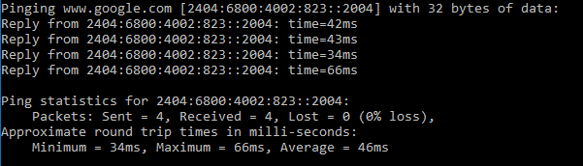
a)ping command

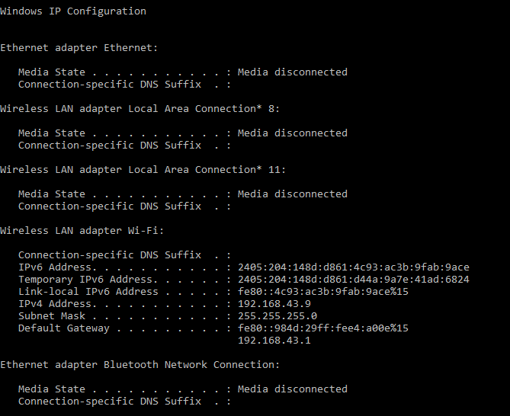
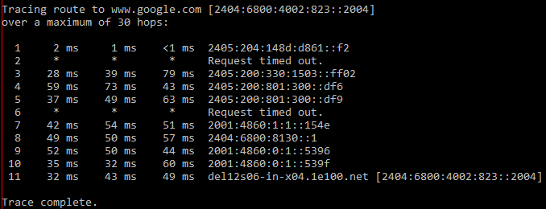
b) ipconfig command

d) arp command
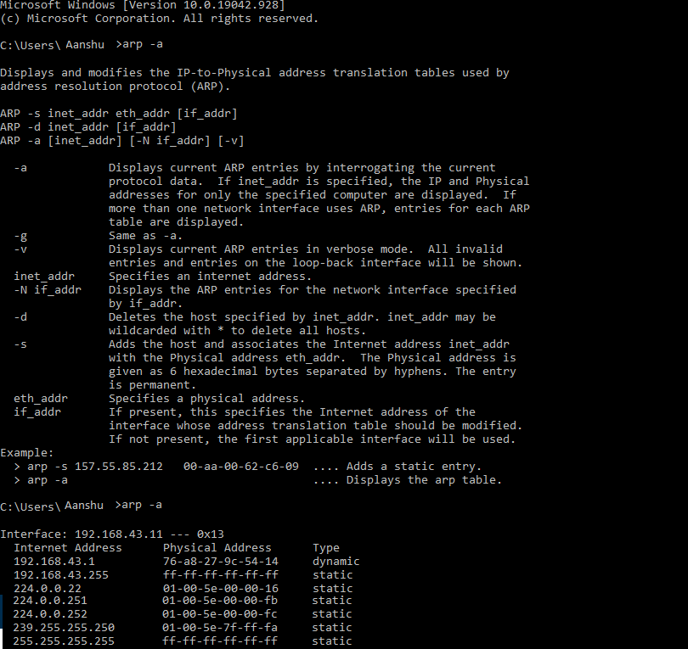
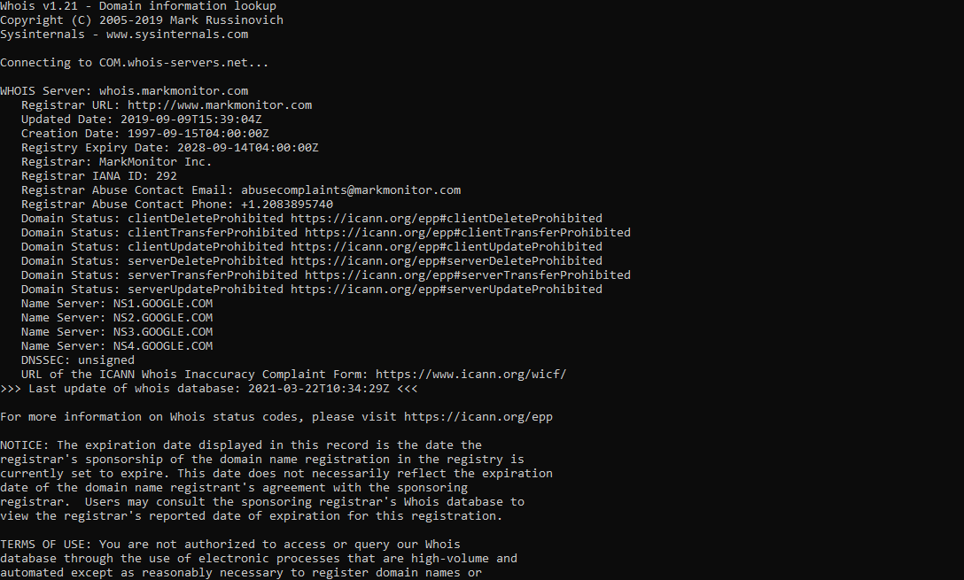
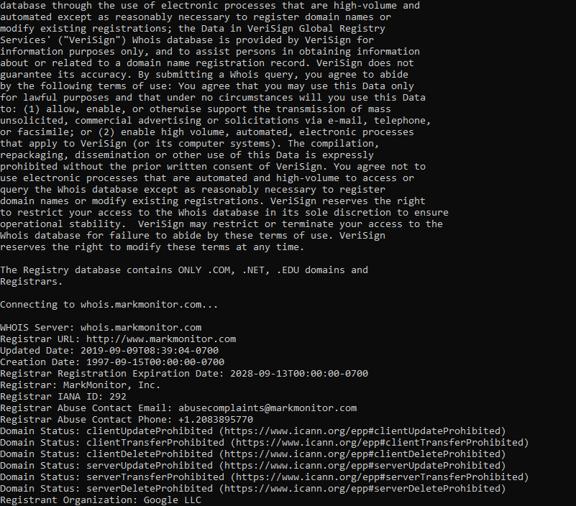
e) whois command

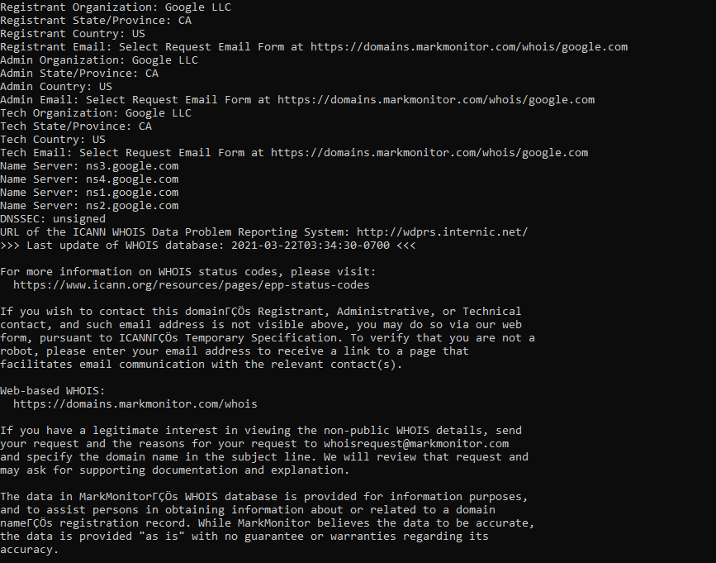
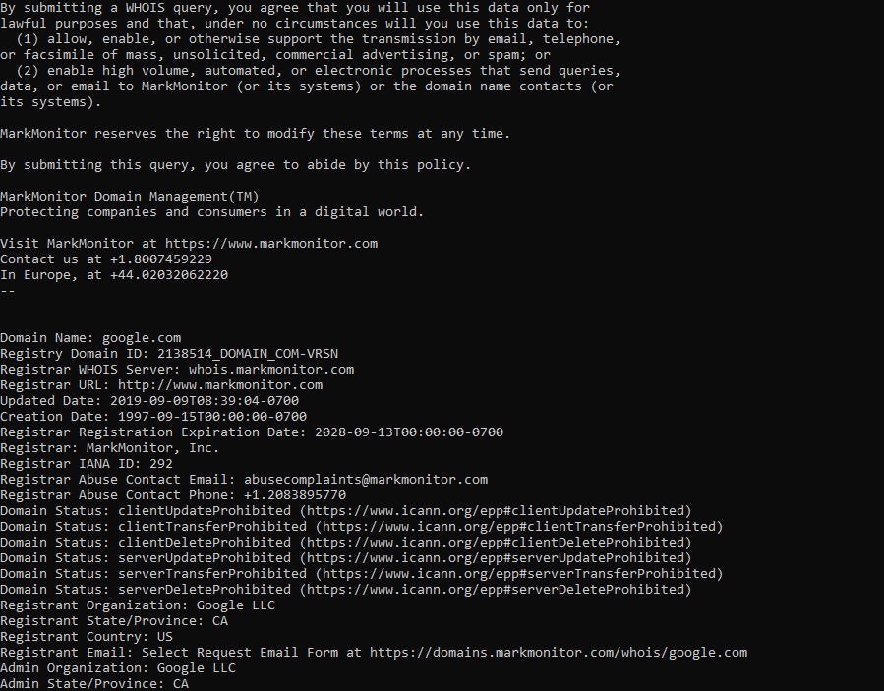

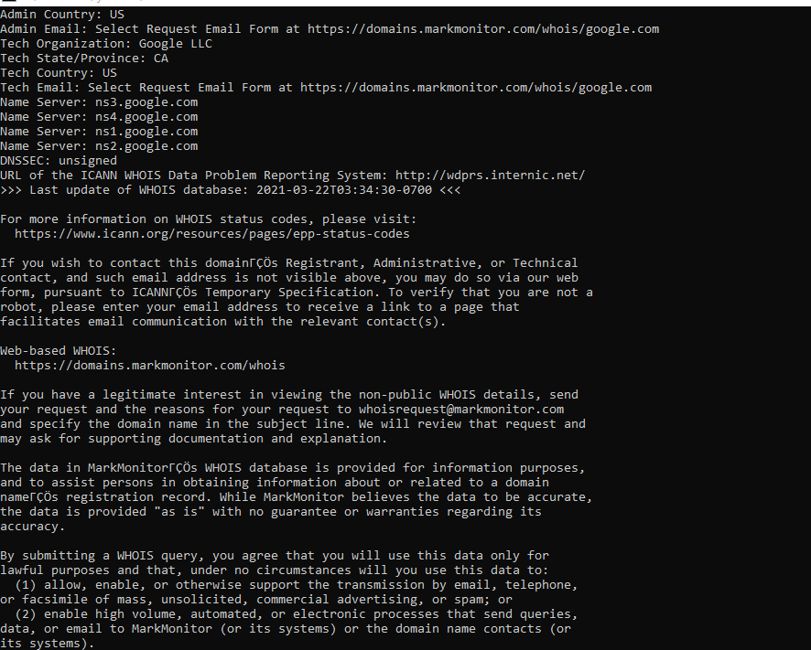

f) netstat command
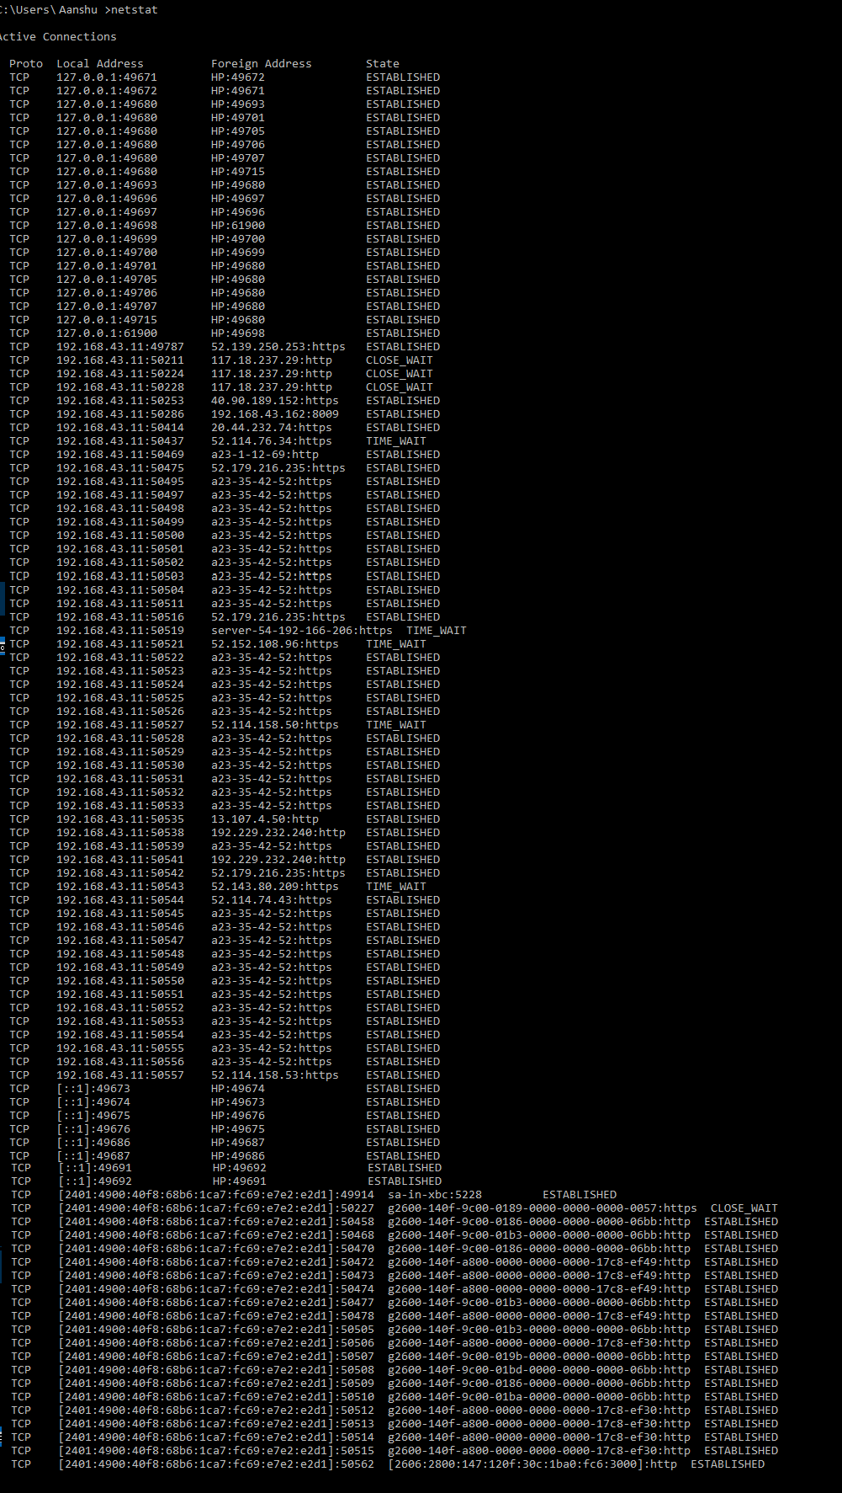

2. Use of Password cracking tools : John the Ripper, Ophcrack. Verify the strength of passwords using these tools.
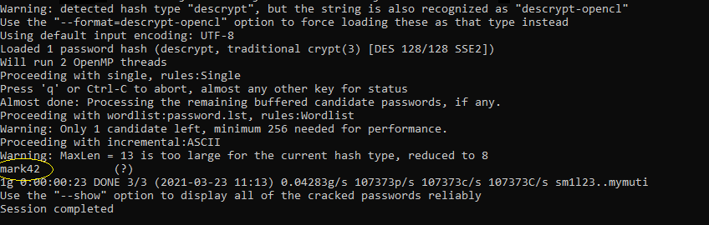

3.Encryption and decryption of Caesar cipher. Write a script for performing these operations.
//Program to encrypt and decrypt ceaser cipher
#include<iostream>
#include<string.h>
using namespace std;
int main()
{
char message[1000],ch;
int i, key=3,choice;
cout<<"Enter text: ";
cin.getline(message,1000);
do{
cout<<"\nMenu\n1.Encryption\n2.Decryption\n3.Exit\n";
cin>>choice;
switch(choice)
{
case 1:for( i = 0; message[i] !='\0';++i)
{
ch=message[i];
if(islower(ch))
{
ch=ch+key;
if(ch>'z')
{
ch=ch-'z'+'a'-1;
}
message[i] = ch;
}
else if(isupper(ch))
{
ch=ch+key;
if(ch>'Z')
{
ch=ch-'Z'+'A'-1;
}
message[i]=ch;
}
}
cout<<"\nEncrypted message:"<<message;
break;
case 2:for(i=0;message[i]!='\0';++i)
{
ch = message[i];
if(islower(ch))
{
ch=ch-key;
if(ch<'a')
{
ch=ch+'z'-'a'+1;
}
message[i]=ch;
}
else if(isupper(ch))
{
ch=ch-key;
if(ch<'A')
{
ch=ch+'Z'-'A'+1;
}
message[i] = ch;
}
}
cout<<"\nDecrypted message:"<< message;
break;
case 3: exit(0);
default: cout<<"Invalid ! ";
}
}while(choice!=3);

return 0;
}
Ouput:
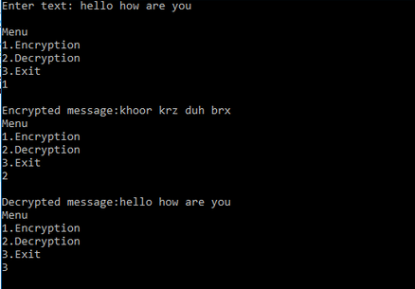
4. Perform encryption and decryption of a Rail fence cipher. Write a script for performing these operations.
//rail fence cipher technique
#include<iostream>
#include<string.h>
using namespace std;

char *encryption(char msg[], int key)
{
int msgLen=strlen(msg), i, j, k = -1, row = 0, col = 0;
char railmat[key][msgLen];

for(i = 0; i < key; ++i)
for(j = 0; j < msgLen; ++j)
railmat[i][j] = '$';

for(i = 0; i < msgLen; ++i){
railmat[row][col++] = msg[i];
if(row == 0 || row == key-1)
k=k*(-1);
row = row + k;
}

cout<<"\nEncrypted Message: ";
for(i = 0; i < key; ++i)
for(j = 0; j < msgLen; ++j)
if(railmat[i][j] != '$')
cout<<railmat[i][j];
}

char *decryption(char msg[], int key)
{
int msgLen = strlen(msg), i, j, k = -1, row = 0, col = 0, m = 0;
char railmat[key][msgLen];

for(i = 0; i < key; i++)
for(j = 0; j < msgLen; j++)
railmat[i][j] = '\n';

for(i = 0; i < msgLen; ++i)
{
railmat[row][col++] = '@';
if(row == 0 || row == key-1)
k= k * (-1);
row = row + k;
}

for(i = 0; i < key; ++i)
for(j = 0; j < msgLen; ++j)
if(railmat[i][j] == '@')
railmat[i][j] = msg[m++];

row = col = 0;
k = -1;

cout<<"\nDecrypted Message: ";

for(i = 0; i < msgLen; ++i)
{
cout<<railmat[row][col++];
if(row == 0 || row == key-1)
k= k * (-1);
row = row + k;
}
}

int main(){
char msg[100],choice;
int key;
do{
cout<<"Enter text(without spaces)"<<endl;
cin>>msg;
key=3;
int opt;
cout<<"Choose option\n1.Encryption\n2.Decryption\n3.Exit"<<endl;
cin>>opt;
switch(opt)
{
case 1 : encryption(msg,key);
break;
case 2 : decryption(msg,key);
break;
case 3 :exit(0);

}
cout<<"\nPress 'y' to continue ";
cin>>choice;
}while(choice=='y');
return 0;
}

Output:
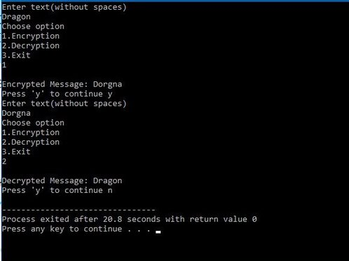

5. Use nmap/zenmap to analyse a remote machine.

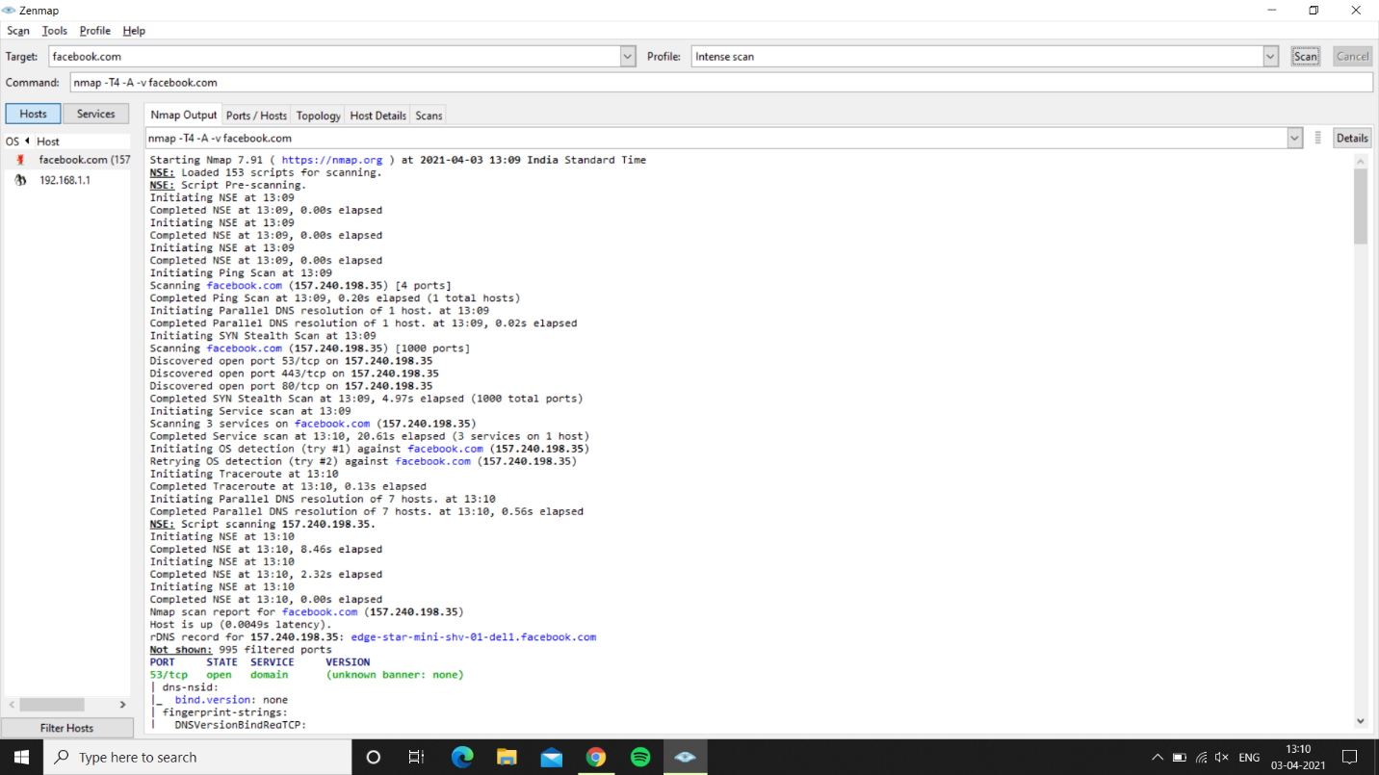

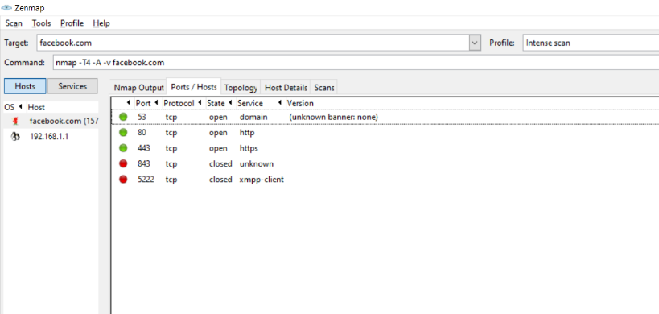

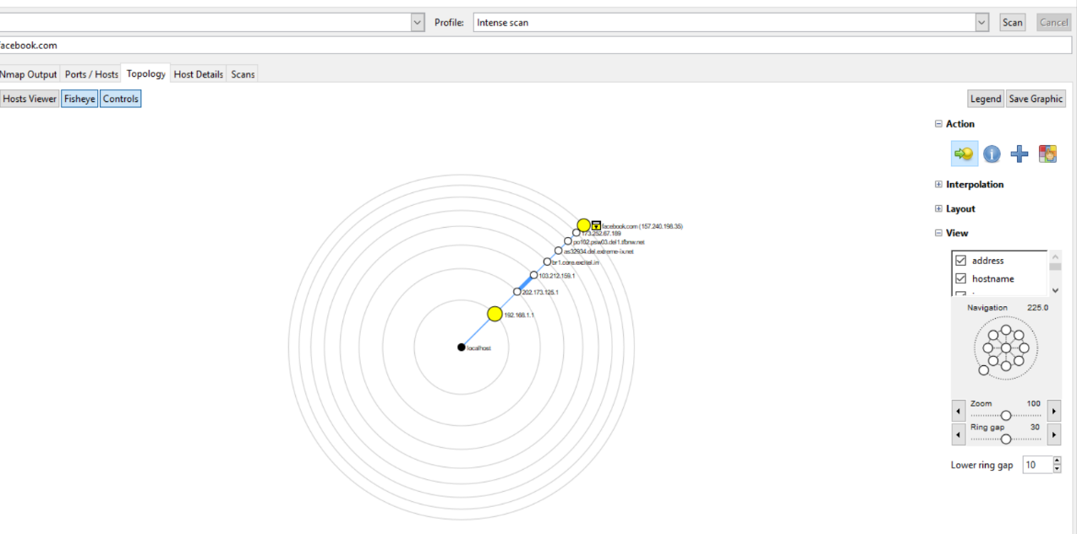

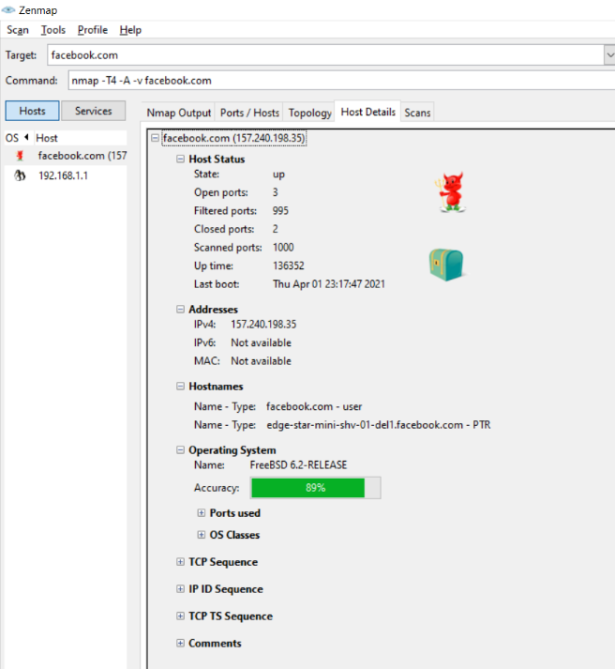

6. Use Burp proxy to capture and modify the message.
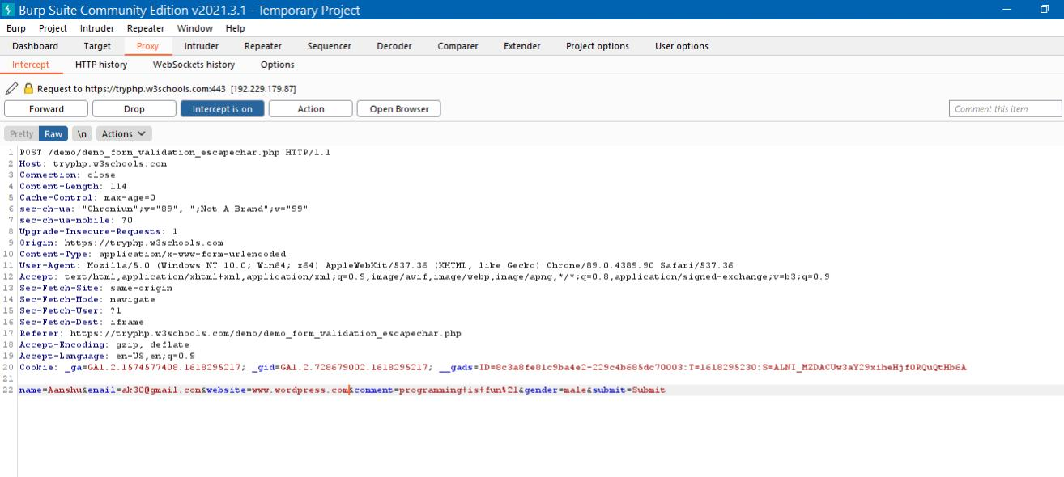

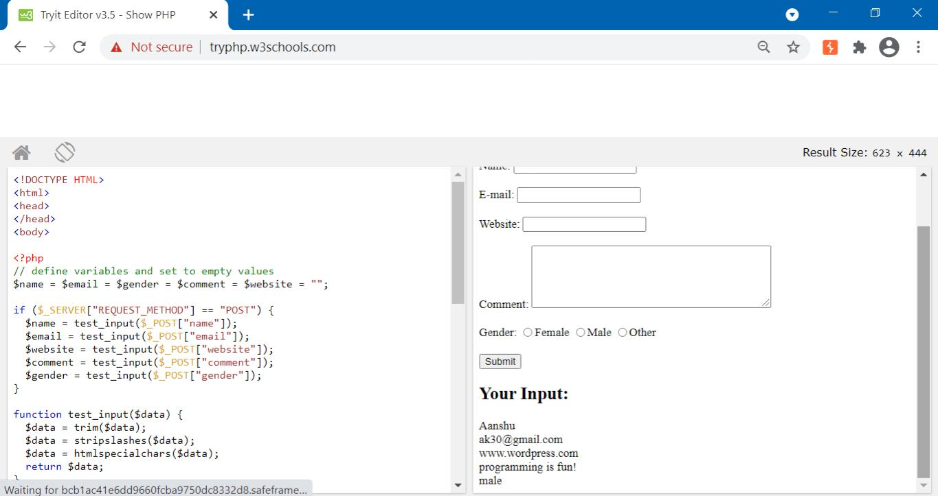

7. Demonstrate sending of a protected word document.
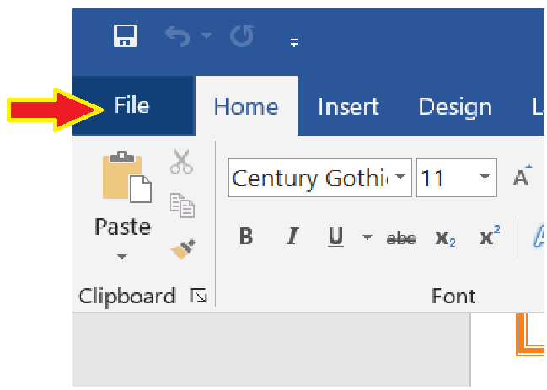

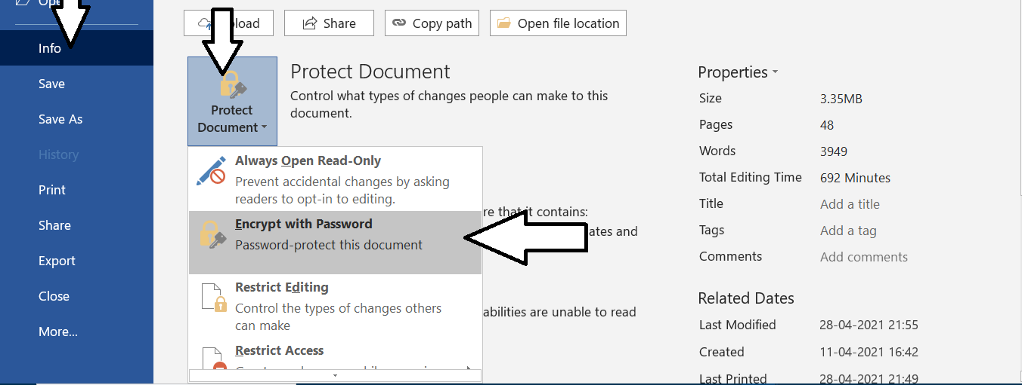

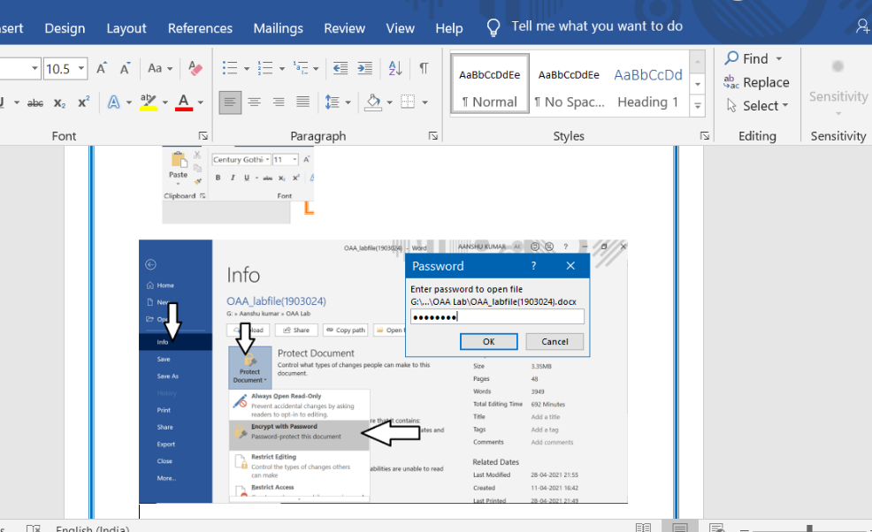

8. Demonstrate sending of a digitally signed document.
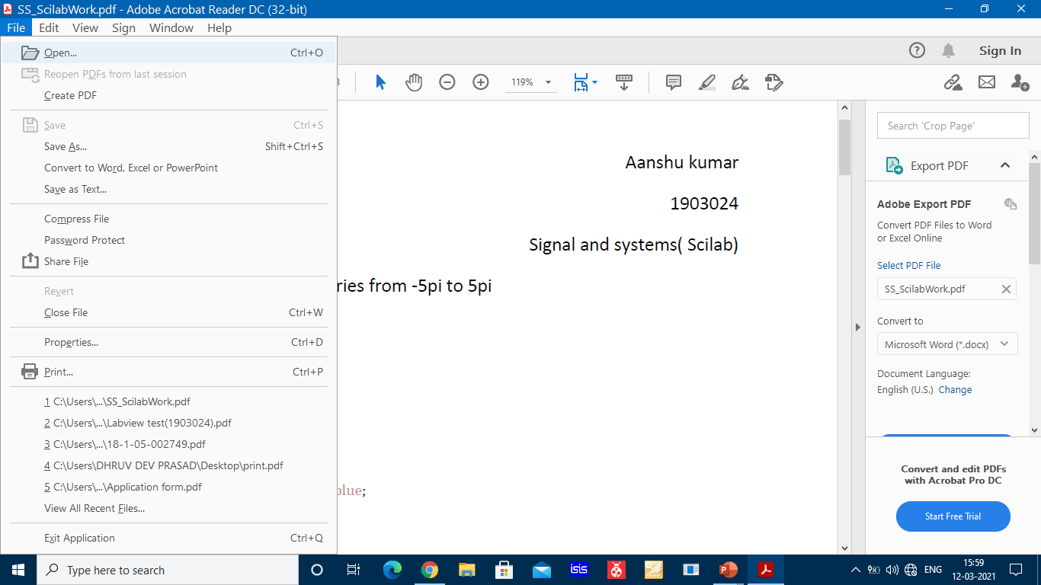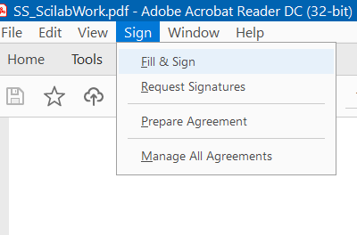

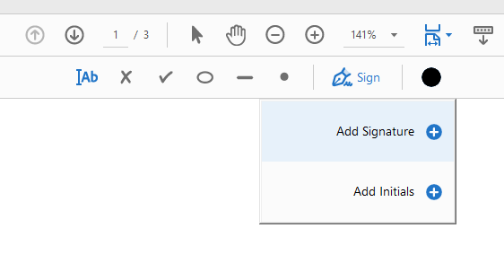

9. Demonstrate sending of a protected worksheet.
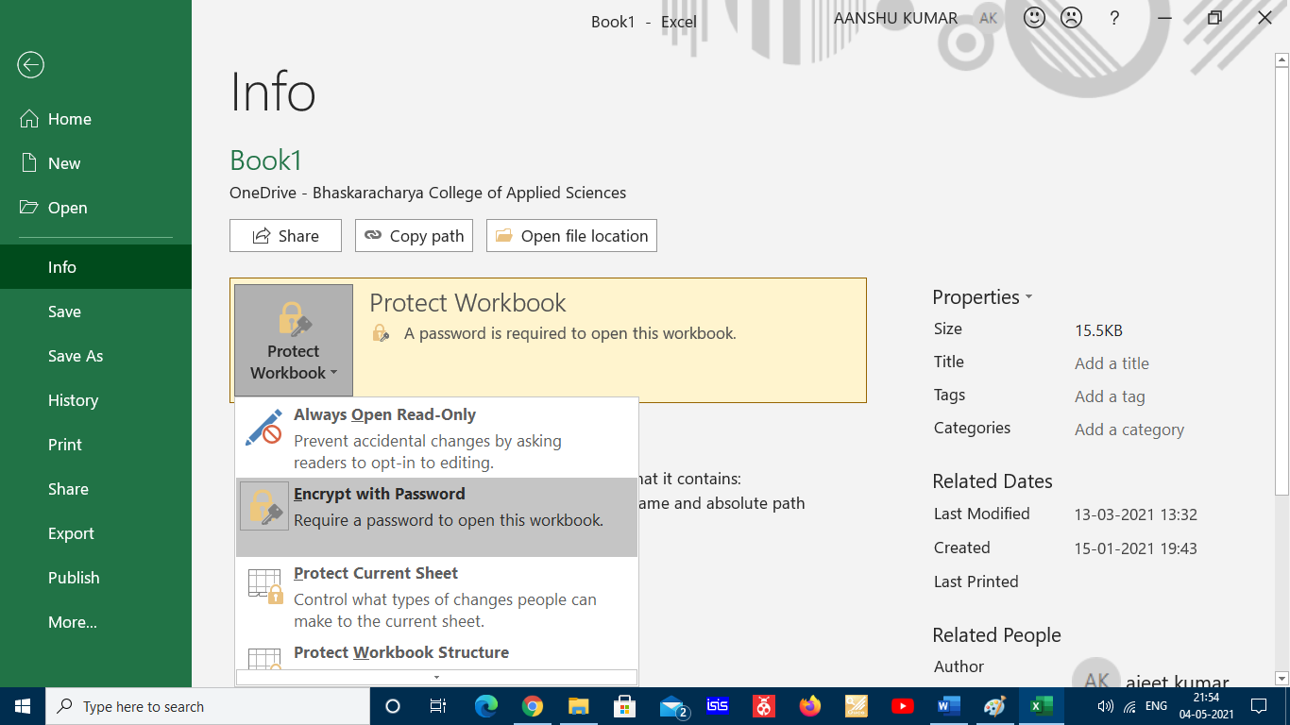
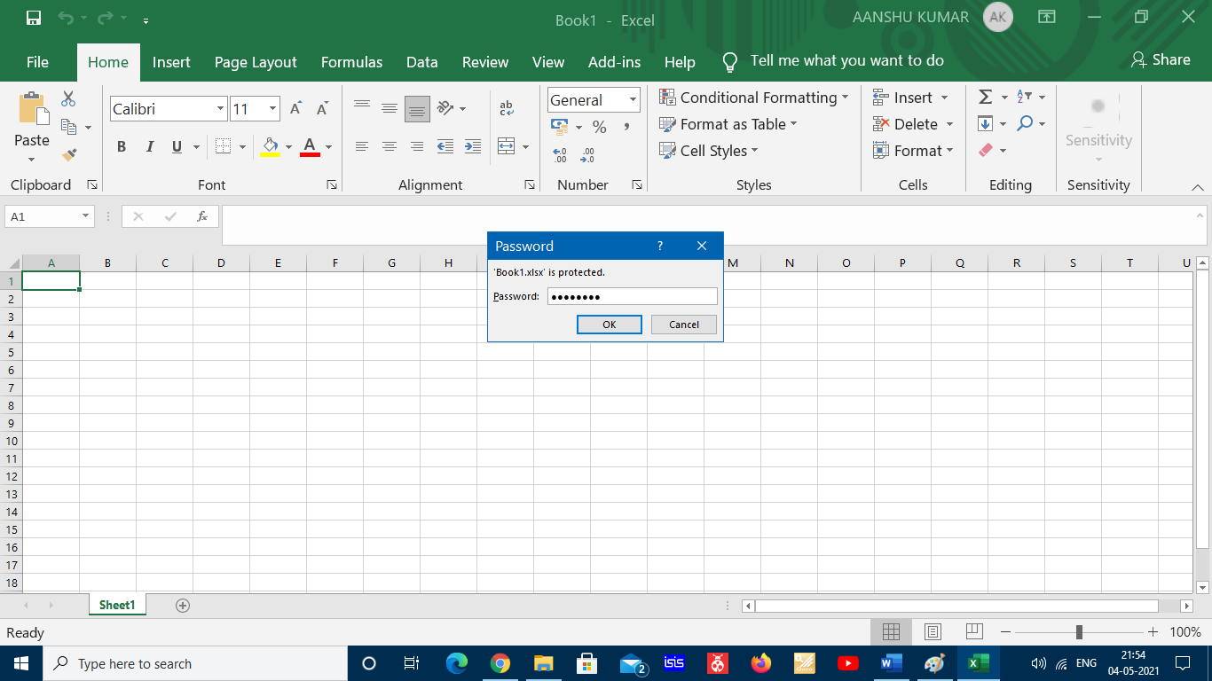

10. Demonstrate use of steganography tools.
Firstly, upload over image and secret file and then download the encrypted file as shown below:
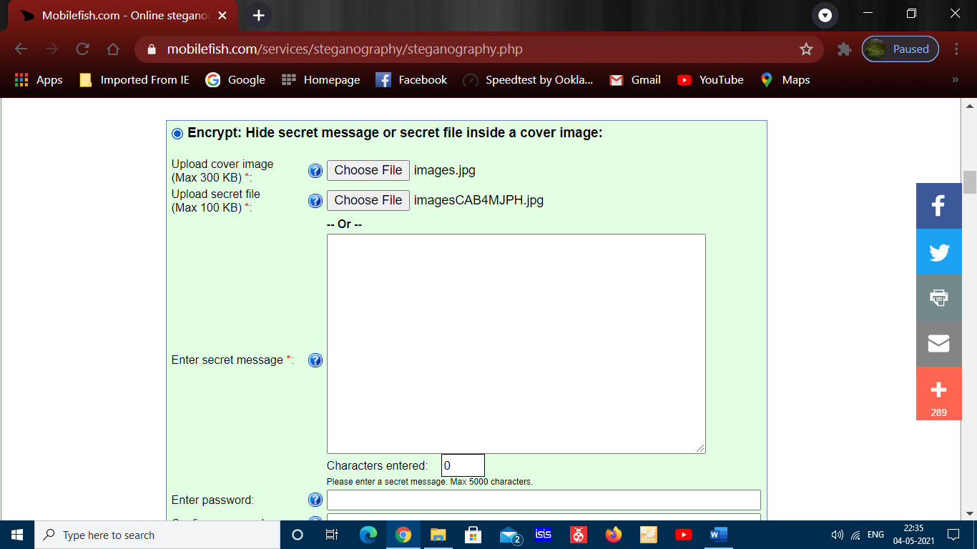

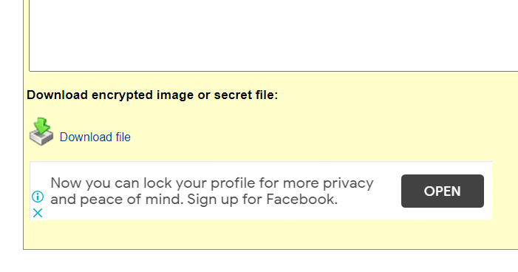
The cover image or encrypted file is shown below:


Now to decrypt the file, go to decrypt option, upload the secret file you downloaded before ,and then click decrypt
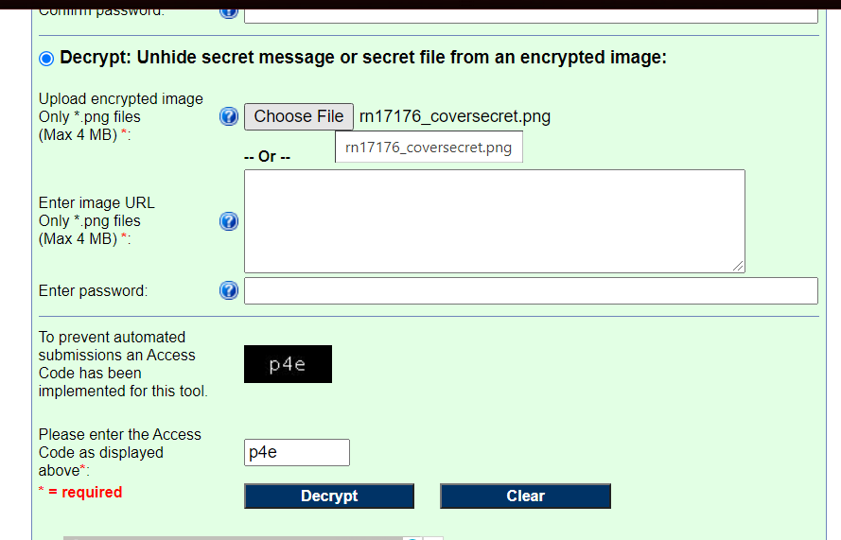

Scroll below , you will get the encypted file and download it as shown below:
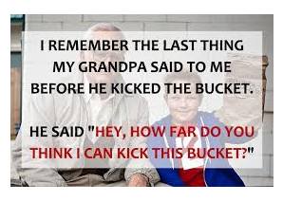

11. Demonstrate use of gpg utility for signing and encrypting purposes.
Public key

Private key

